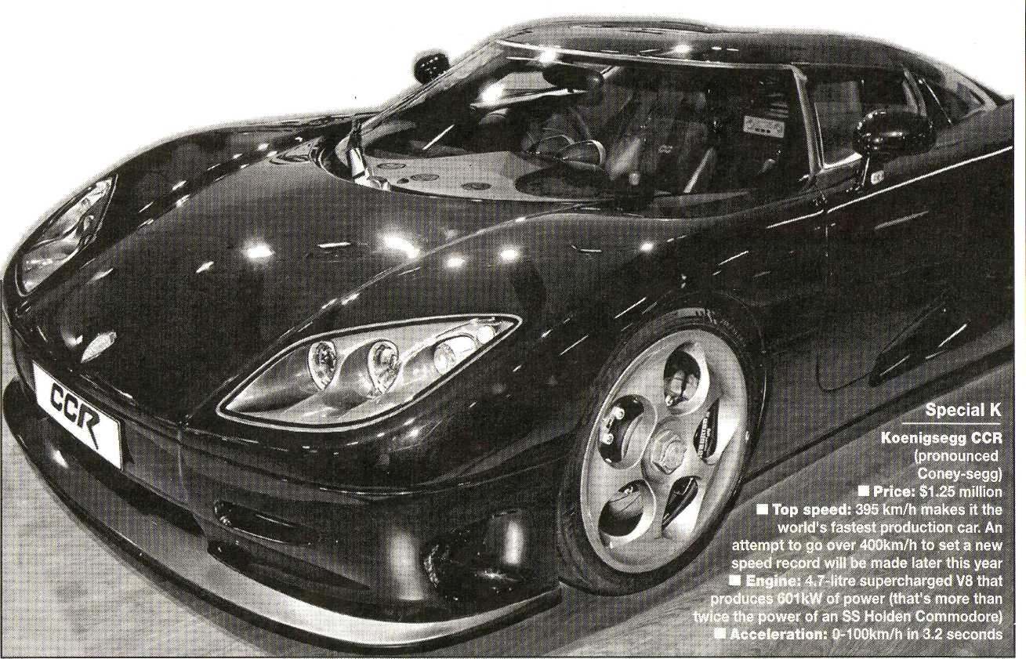
Three order seats on a $1.25m drive

By KEVIN HEPWORTH

. LIFE in the fast lane is set to become a blur for an elite trio of Sydney's super-rich.
Three of the city's 40-something property developers have slapped down a $250,000 deposit to secure a substantial piece of automotive bling — Sweden's Koenigsegg CCR supercar.
The car was featured on the cover of the Australian International Motor Show official program, published by The Daily Telegraph last week.
Importers, Gallery of Veloce in Rose Bay have three firm orders for the $1.25 million street rocket, all taken since the car went on display at the motor show on Thursday
"We had interest in the car since it was known that we were importing it but to get these orders in the first three days is stunning," Gallery of Veloce sales manager Con Hrysan-thos said.
"The three firm orders are all from Sydney, all have property development as their core business and all are in their 40s."
As owners of Koenigseggs the fortunate trio will be able to zip from standstill to 100km/h in a blinding 3.2 seconds on their way to a top speed of 395km/h.
"The cars each take about three months to build and apart from the show car our first allocation is in
February," Mr Hrysanthos said. "It will probably be another nine months after that before the third car is available."
The Koenigsegg — only 15-20 of which are handmade in Sweden each year — is one in a rarefied collection of $lm-plus supercars at the motor show.
The exclusive club also includes the Maserati MC12, Porsche's Carrera GT and the beautiful Pagani Zonda.
Maserati have taken orders for two of their $1.8 million stars and Pagani importers Motor Group Australia have fielded substantial interest but are not taking deposits until the car has been certified for sale in Australia. • TODAY is Ladies Day at the motor show at Darling Harbour.
Highlights include fashion parades by Country Road at noon, 3pm, 6.30pm and 8pm.
Free gift bags of cosmetics, chocolates, magazines and other products will be given to women who attend the parades.
And there is a major prize for the first woman to enter the show today after the 150,000th person arrives.
She will win Maserati clothing and then go with a friend on a chauffeur-driven day out including a visit to a health spa and lunch courtesy of Maserati.
□ Get the latest motor show news on The Daily Telegraph's official show website. Visit www.australian motorshow.com

